

**CSF 3133: Reka Bentuk Antara Muka**

**Berasaskan Web**

**Name: Lim Jun Han**

**Matric No.: S76171**

**Supervisor:**

**Assoc. Prof. Ts. Dr. Wan Nural Jawahir Wan Yussof**

**2.3 Working with Tables**

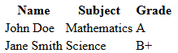

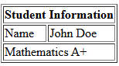

**2.4 Creating Forms**

**2.4.1 Basic Form Elements**

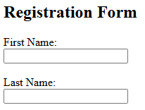

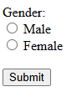

**2.4.2 Other Form Elements**

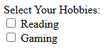

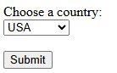

**2.5 Semantic HTML**

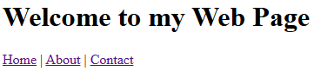

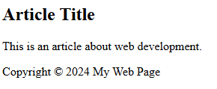

**2.6 Lab Exercise**

**Source Code**

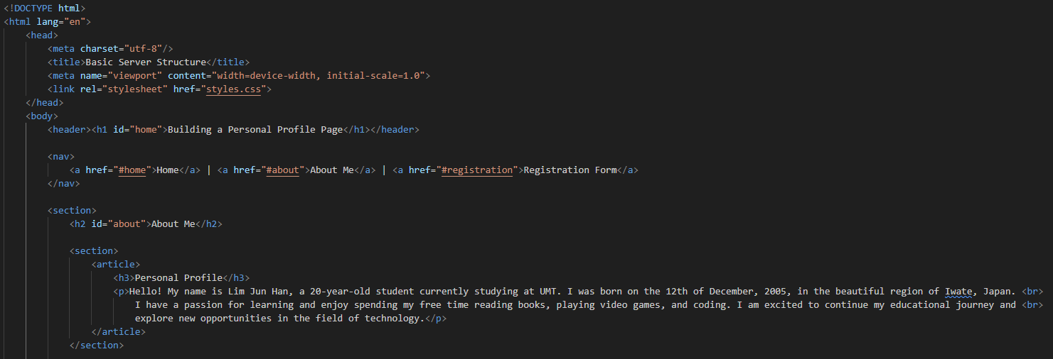

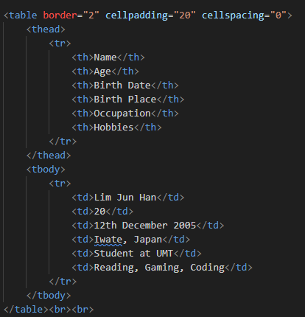

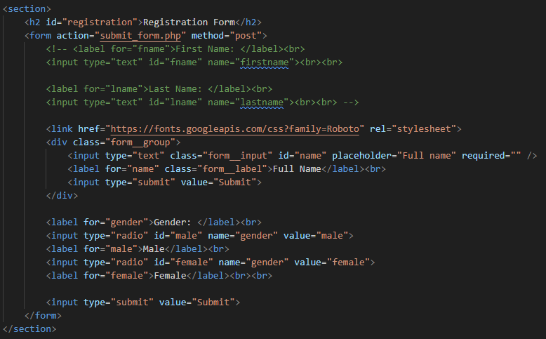

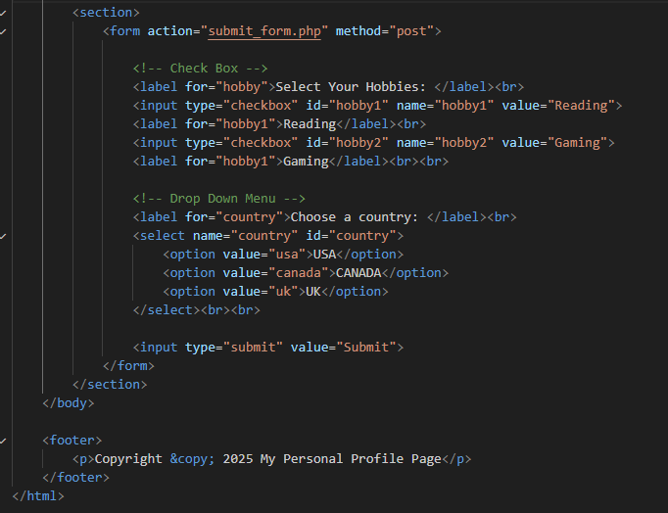

**Web View**

